Question 2

(a.1)

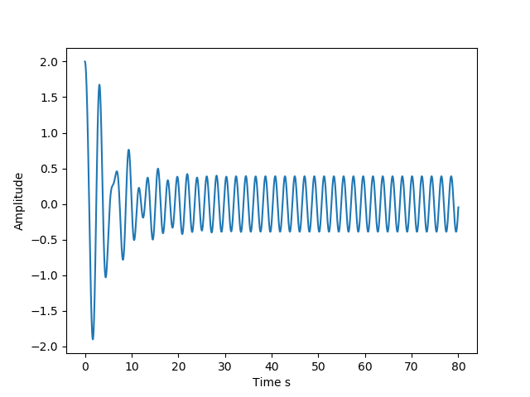

(a.2)

* The angular frequency will match that of the driving force, meaning that it will be 3 rad s­­­­-1
* I found the amplitude of these oscillations to be 0.39

(b.1)

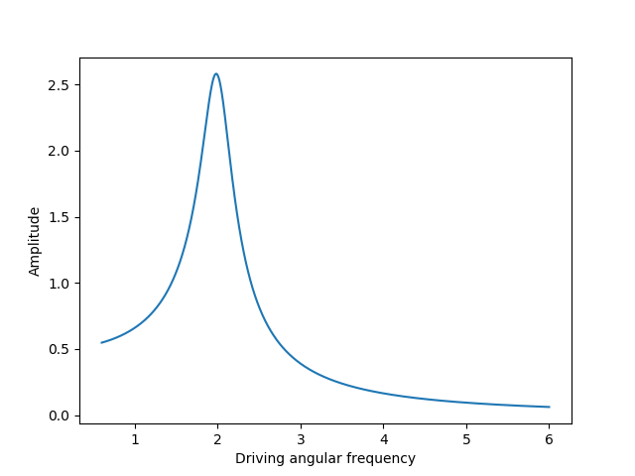

The driving frequency that gives the maximum amplitude of oscillation in my code is 1.984.

This value matches the expected value of 1.989, which is the angular frequency of the system without a driving force.

If the driving force and the system have different angular frequencies, then they will apply opposing forces, causing them to decrease in amplitude, however, if they have the same frequency, they will constructively interfere in a sense and combine to form a larger amplitude.